**Module 3 Lesson Plan**

**Module 3 Transport Layer**

We read in chapter 2, that **TCP provides a reliable, connection-oriented service** to the invoking application.

Let us find out what is an **rdt (reliable data transfer) protocol**, and why and how we can improve it to make it a reliable protocol.

A transport protocol is said to be **reliable** if *(the service abstraction it provides to the upper-layer*  is “**no transferred data bits are corrupted** (flipped from 0 to 1, or vice versa) **or lost**, and **all are delivered in the order in which they were sent”**.

Please note that this is a **service abstraction** since the layer below the reliable data transfer protocol may be unreliable.



In section 3.4, we started building a transport protocol from scratch, and several attempts were made to improve that protocol.

Discussion 7

We reached the conclusion that Acknowledgment/Negative Acknowledgments are needed from receiver to sender. Why?

Discussion 7 Answer:

These control messages allow the receiver to let the sender know what has been received correctly, and what has been received in error and thus requires repeating.

**Question 1:**

a) In the rdt protocols, why did we need to introduce sequence numbers?

Solution:

The problems with duplicate packets is that the receiver doesn’t know whether the ACK or NAK it last sent was received correctly at the sender. Thus, it cannot know a priori whether an arriving packet contains new data or is a retransmission!

S

R

P

A

Receive ACK, send new Packet, or didn’t receive ACK, resend old Packet

Sequence numbers are required for a receiver to find out whether an arriving packet contains new data or is a retransmission.

Discussion 8

In our preliminary design of a reliable data transfer protocol, we introduced the concept of ACK and NAK. But we then disregarded NAK, and we kept using ACK. Why? How can we tell the sender that a packet is corrupted?

Discussion 8 Answer:

We can accomplish the same effect as a NAK if, instead of sending a NAK, we send an ACK for the last correctly received packet. A sender that receives two ACKs for the same packet (that is, receives duplicate ACKs) knows that the receiver did not correctly receive the packet following the packet that is being ACKed twice.

**Question 1:**

b) In the *rdt* protocols, why did we need to introduce timers?

Answer:

Timers are needed to handle losses in the channel. If the ACK for a transmitted packet is not received within the duration of the timer for the packet, the packet (or its ACK) is assumed to have been lost. Hence, the packet is retransmitted.

Discussion 9

What is a stop-and-wait protocol? Do you think it is widely implemented in network design?

Discussion 9 Answer:

In a stop-and-wait protocol, the sender will **not send a new piece** of data **until** it is sure that the receiver has **correctly** **received** the current packet.

Stop-and-wait protocols result in a **very low utilization** of the bandwidth and the network resources.

Discussion 10 The sender Utilization of a stop-and wait protocol is defined as the fraction of time the sender is actually busy sending bits into the channel:

**Usender = Ttr /(Ttr + Wwait time before another packet can be transmitted)**

Consider two hosts 1000Km apart. Host A is sending a message of size 1000Bytes to host B. A can transmit at a rate of 2Mbps. Suppose bits travel at the speed of 200,000,000 m/sec.

Find the utilization of the sender (host A):

Discussion 10 Solution:

Ttr = Length of packet/ Bit rate = 1000 Bytes/2,000,000 bps = 1000*8 bits/2,000,000 bps=4 msec

Wait time = RTT for packet to arrive to receiver, and ACK to go from Receiver to Sender

Wait time = RTT= 2* Tpropagation (since transmission time of ACK is negligible) = 2* distance/speed

= 2*1,000,000 m / 200,000,000 (m/sec) = 0.01 sec = 10 msec

Usender = Ttr / (Ttr + Wwait time before another packet can be ransmitted) = 4/(4+10) = 28.6% => the sender is idle most of the time

**Question 2:**

Give a trace of the operation of protocol rdt3.0 similar to that used in Figure 3.16 in the following cases:

1. packets M0 is corrupted. rdt 3.0 is a stop-and-wait protocol

M0 → A0 → M1 → A1 , then **M0(corrupted)**



**.**

**.**

b) Acknowledgement 0 is corrupted.



M1

A1

a1

M0

A0

a1

M0

A0

M1

M1

M0

M0

**What is an alternative to stop-and-wait protocols?**

**Pipelined Reliable Data Transfer Protocols**

Rather than operate in a stop-and-wait manner, the sender is allowed to send multiple packets without waiting for acknowledgments.

ex: if the sender is allowed to transmit three packets before having to wait for acknowledgments, the utilization of the sender is essentially tripled.



Since the many in-transit sender-to-receiver packets can be visualized as filling a pipeline, this technique is known as **pipelining**.

**the sequence number space must be at least twice as large as the window size, *k*≥2*w* to avoid confusing retransmission packets with newly transmitted packets with same sequence number.**

 





Pipelining has the following consequences for reliable data transfer protocols:

* The range of sequence numbers must be increased.
* The sender and/or receiver sides of the protocols may have to buffer more than one packet. (For ex. the sender will have to buffer packets that have been transmitted but not yet acknowledged).
* Buffering of correctly received packets may also be needed at the receiver.
* The range of sequence numbers needed and the buffering requirements will depend on the manner in which a data transfer protocol responds to lost, corrupted, and overly delayed packets.
* Two basic approaches toward pipelined error recovery can be identified: **Go-Back-N** and **selective repeat**.

In a **Go-Back-N (GBN) protocol**, the sender is allowed to transmit multiple packets (when available) without waiting for an acknowledgment, but is constrained to have **no more than some maximum allowable number, *N,* of unacknowledged packets in the pipeline. Why?**

*base+N-1*



*base*: the sequence number of the oldest unacknowledged.

As the protocol operates and more packets are acknowledged, this window slides forward over the sequence number space. GBN protocol is a **sliding-window protocol**. A limited N is needed for flow control and congestion control.

**Figure 3.20 Extended FSM description of the GBN sender**

**Go-Back-N (GBN)**



If an ACK is received, it acknowledges all packets before it. base is updated to its acknum+1: **cumulative acknowledgment**

No action is done at sender when duplicate ACK are received.

(sender receives ACK:)

if ACK is corrupted, don’t update anything

A timer is used for each transmitted packet. If a **timeout occurs**, the sender resends ***all*** packets in the sliding window.

In a real implementation: this data is buffered or there should be a synchronization mechanism (a flag) that would allow the upper layer to call *rdt_send()* only when the window is not full.

start

*rdt_send()* is called from above

**1**

**3**

**2**



The GBN sender’s actions:

* (if the sliding window is not full), data is accepted from the application layer, a sequence number is added to it (plus additional bits), and the packet is sent
* A timer is set for each transmitted packet. If a timeout occurs, the sender resends all packets in the sliding window.
* If an ACK is received, it acknowledges all packets before it. base is updated to its acknum+1: cumulative acknowledgment
* No action is done at sender when duplicate ACK are received.

The **receiver’s actions** in **GBN** are simple.

* If a packet with sequence number *n* is **received correctly and is in order** (i.e. after delivering a packet with sequence number n-1), the receiver **sends an ACK** for packet *n* and **delivers the data** portion of the packet to the upper layer.
* In all other cases, the **receiver discards** the packet and **resends an ACK** for the **most recently received in-order** packet.

**Question 2:**

Visit the **Go-Back-N** Java applet at the companion Web site:

<https://media.pearsoncmg.com/aw/ecs_kurose_compnetwork_7/cw/#interactiveanimations>

(**choose interactive animations, then chapter 3 Go-back-N**)

1. **Choose “faster” option**. Have the source send five packets (**click quickly 5 times on Send new**).

Describe what happens.

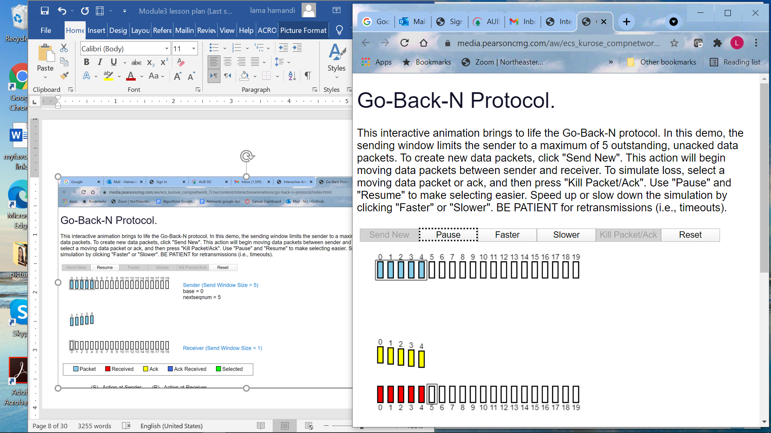

1. Once all packets arrive successfully to receiver , 5 acknowledgments (drawn in yellow) are sent from sender to receiver

2. **Choose “faster” option**. Have the source send five packets (**click quickly 5 times on Send new**), and then **pause** the animation before any of the five packets reach the destination. Then kill the first packet: **click on packet 0** and select **kill packet**. Then **resume** the animation.

Describe what happens.

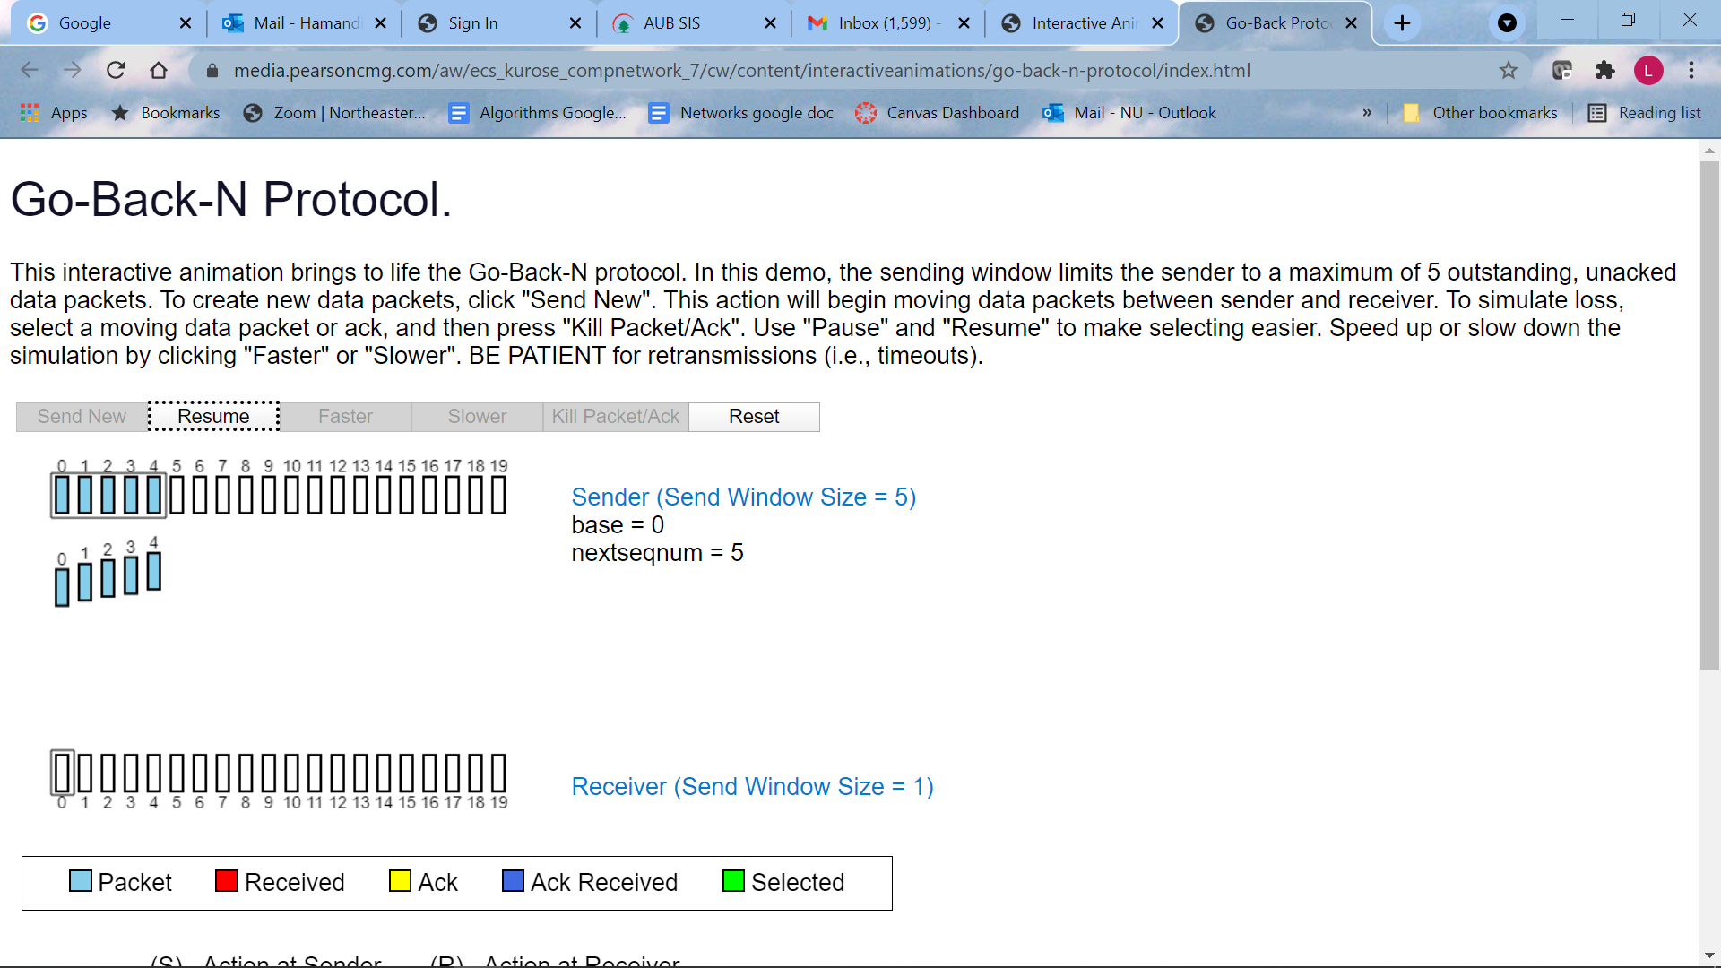

a) 5 packets were sent

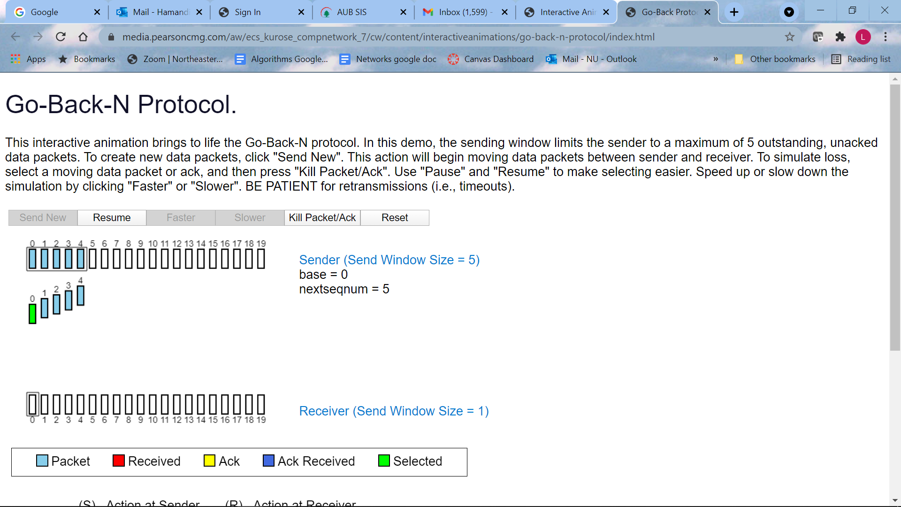

b) Packet 0 is selected then killed

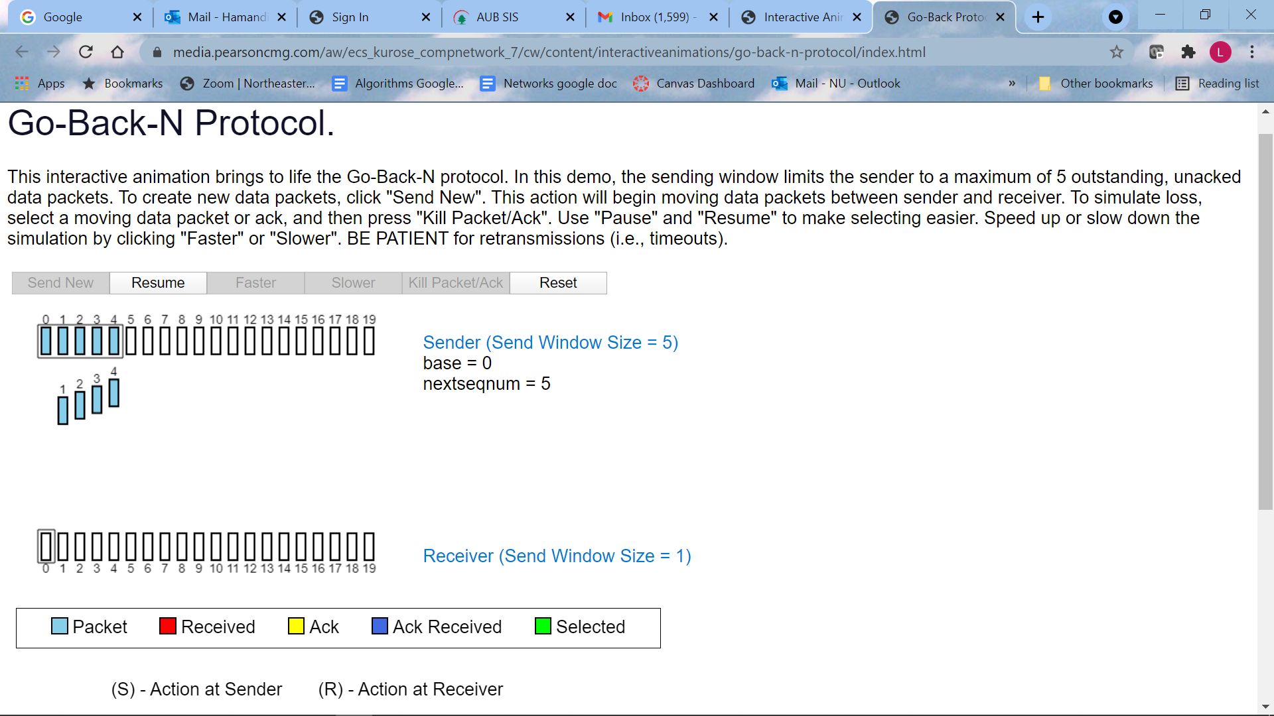

c) packet 0 is lost

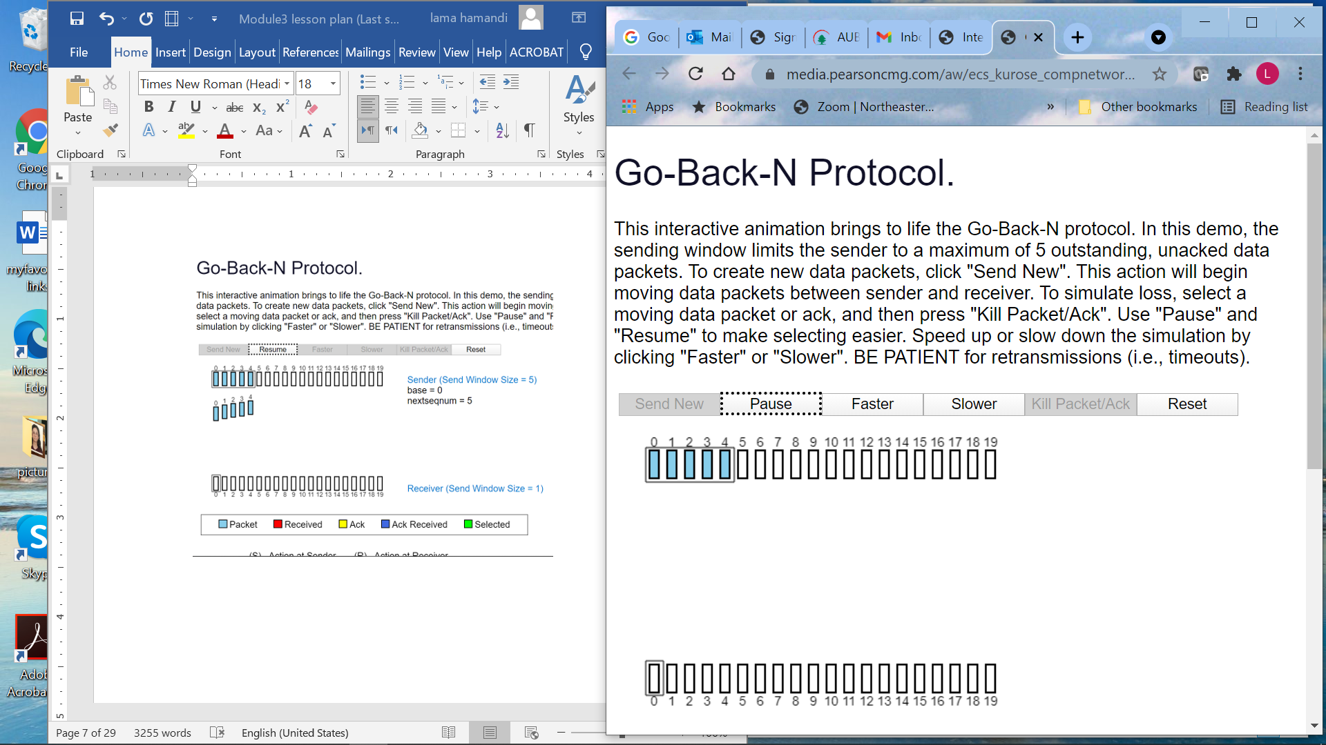

d) receiver discarded all packets.

Nothing is kept in receiver

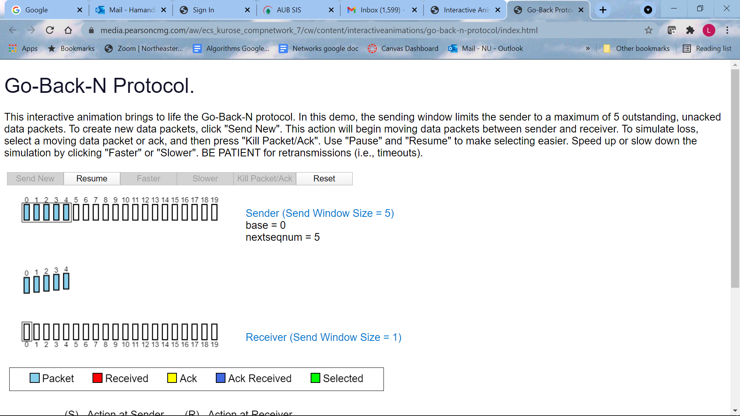

e) After timeout, sender sends all 5 packets: the lost packet and all packets sent after it

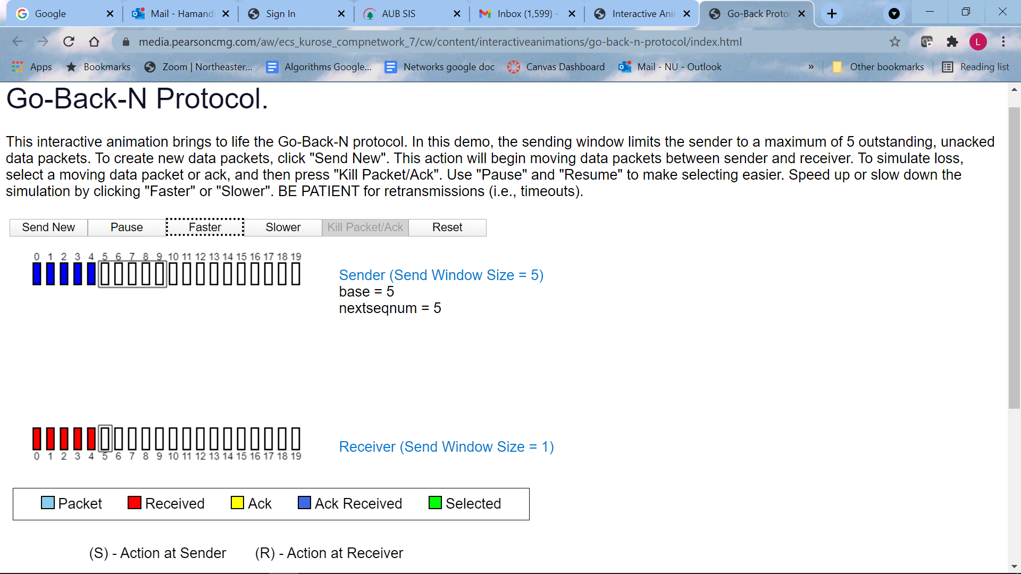

g) the 5 ACK are received by sender. The window slides 5 positions to the right, since all 5 packets were acknowledged.

3. Repeat the experiment, but now let the first packet reach the destination and kill the first acknowledgment. Describe again what happens.

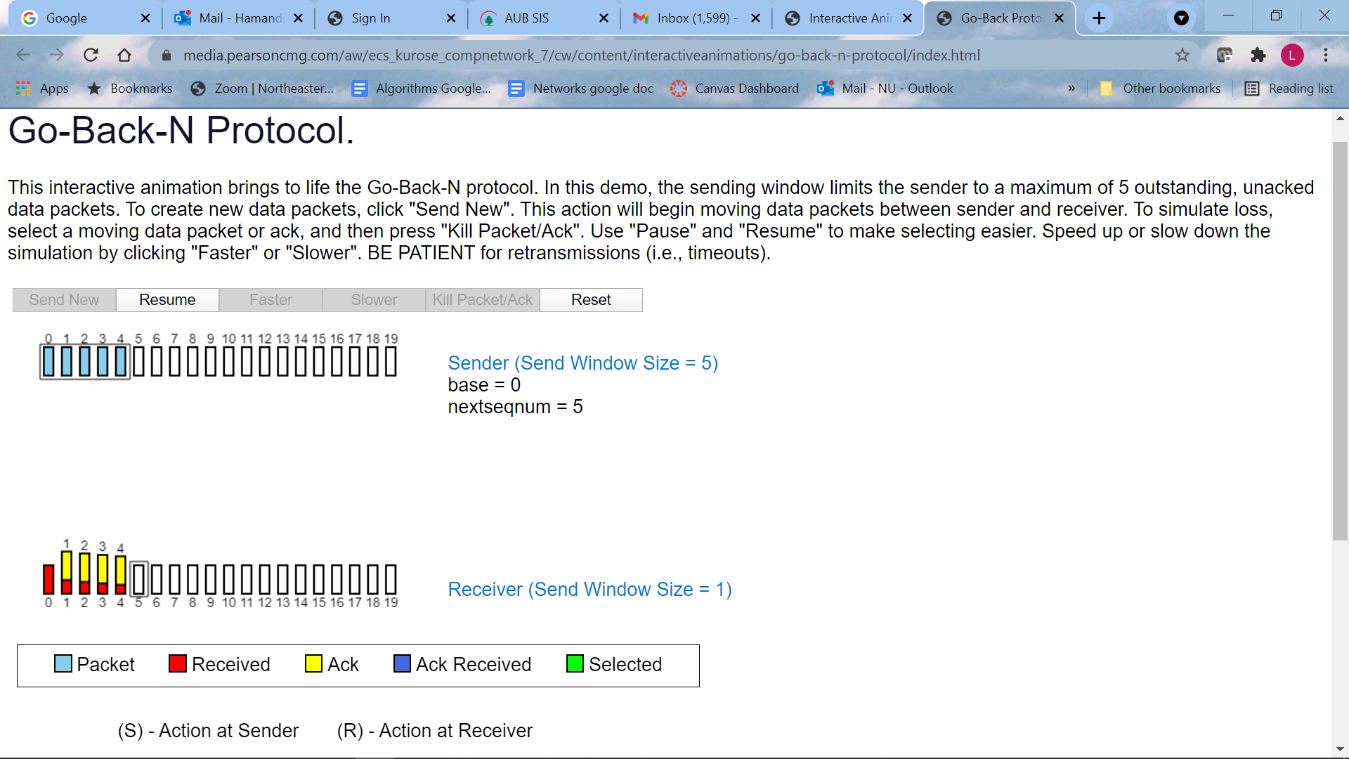

a) ACK0 is lost



b) When ACK1 to ACK4 were received by sender, all packets 0 to 4 are marked as acknowledged, and window slides to right. :An ACK of packet i when received by sender, acknowledges **all packets before it**: cumulative Acknowledgment

3. Finally, try sending six packets. What happens?

The 6th packet is not sent since the window is of size 5.

**Discussion 11: Repeat the Go-Back-N animation: send 5 packets (0 to 4), then pause animation, and kill packet 1. Describe what happens:**

**Are acknowledgments sent?**

**If packet #5 arrives to sender can it be sent?**

**What happens next?**

**Answer**

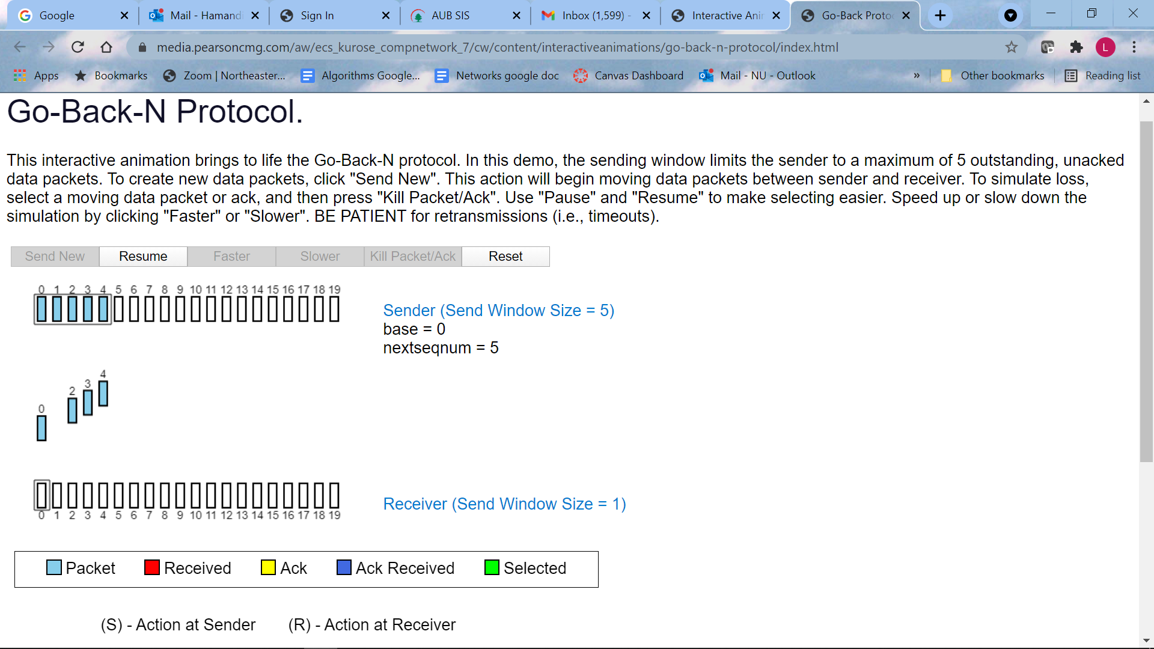

A) packet 1 is lost

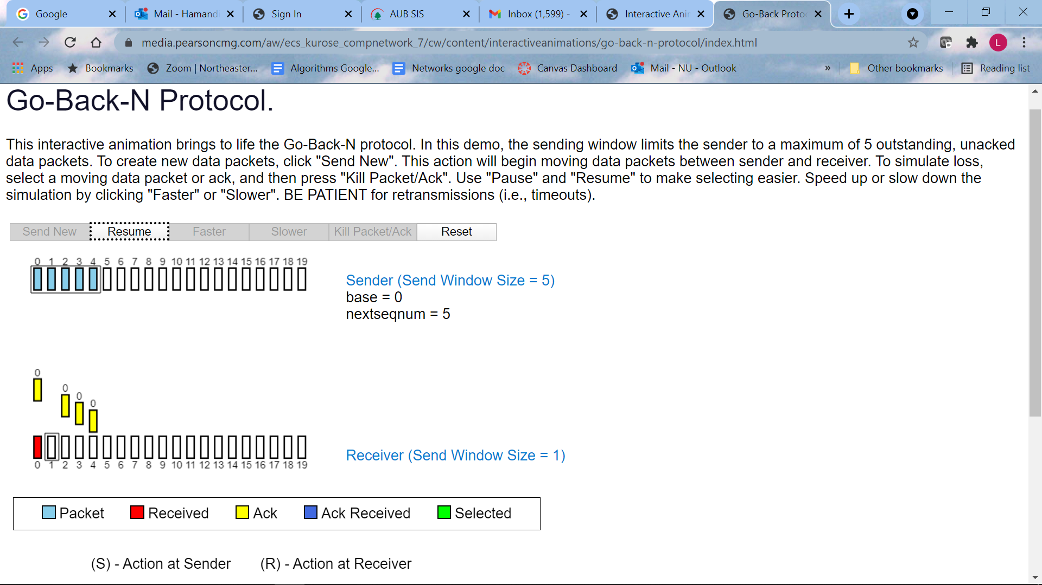

B) All acknowledgements have the sequence # 0 in them ( 0 is the last packet received correctly at receiver)

Note: receiver discards Packets 2, 3 and 4

How is the sliding window changed?

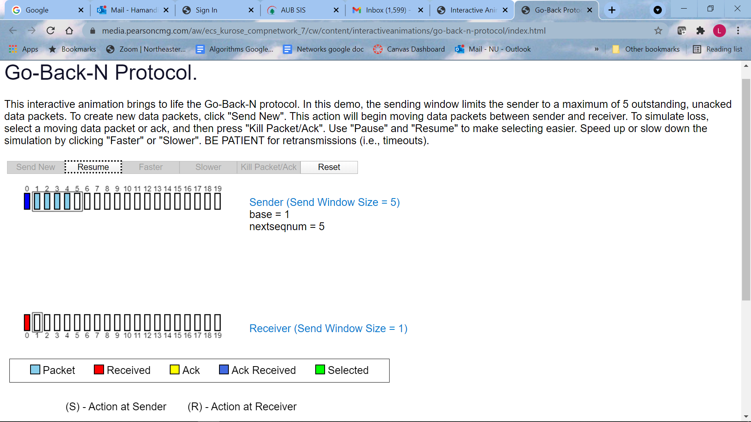

C) Only packet0 is acknowledged. Sliding window advances one position only to the right.

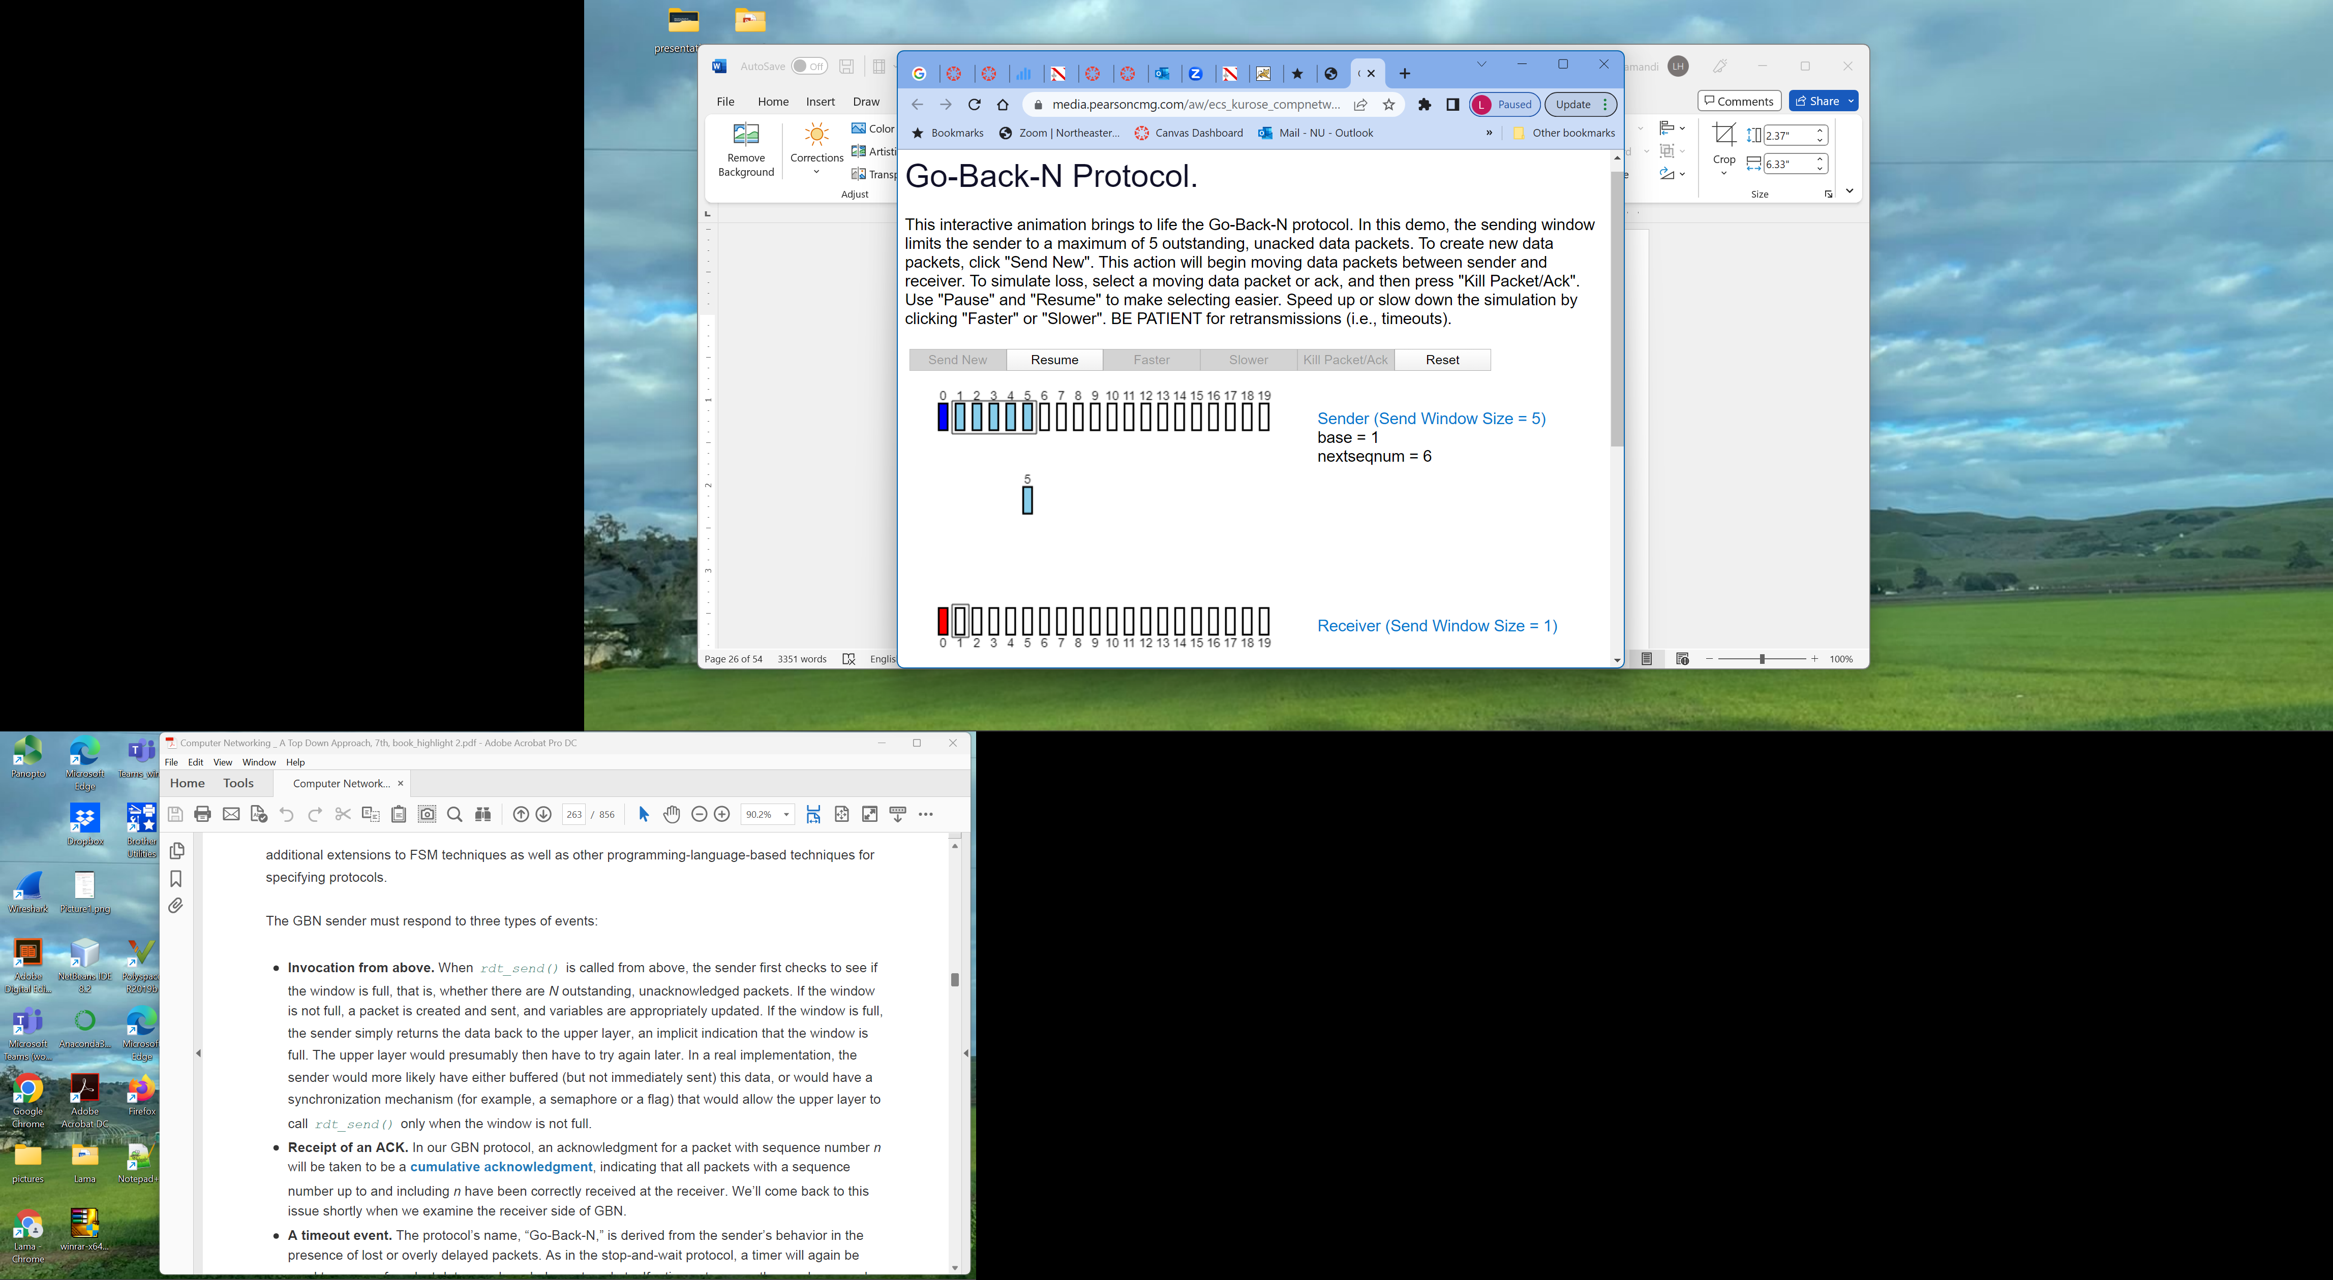

What happens if packet 5 is sent?

(why packets 1, 2, 3, 4 are not resent??)

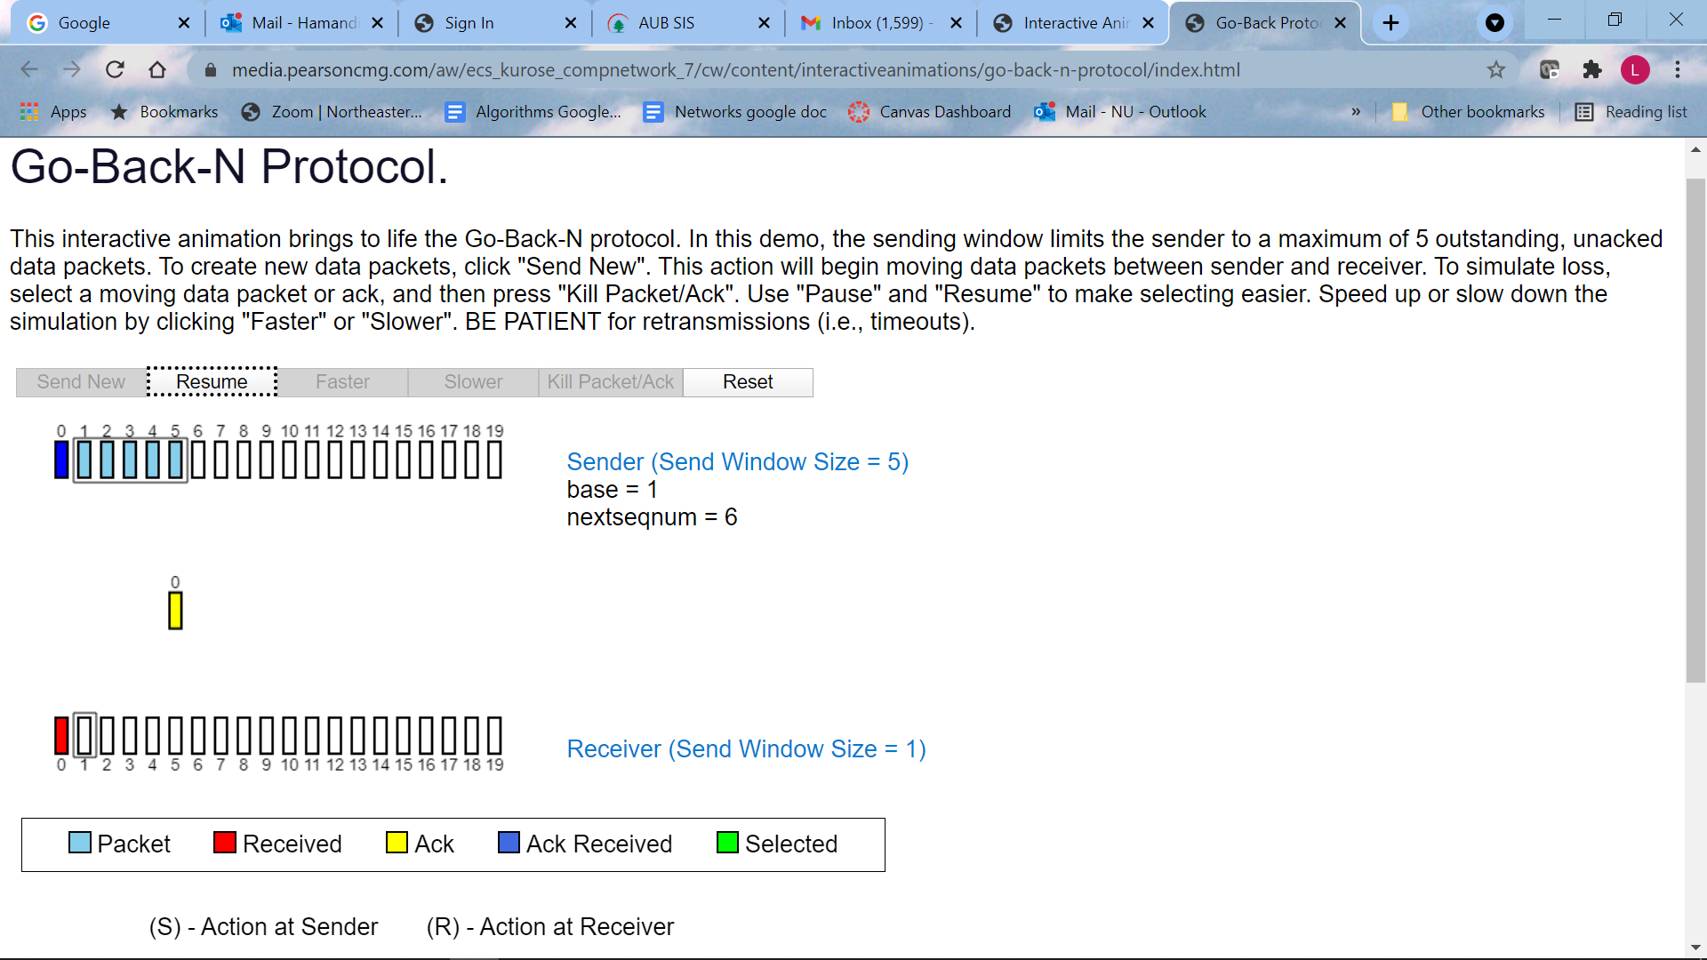

E) Since packets 1, 2, 3, 4 are not received at receiver and not acknowledged, the acknowledgment after packet 5 is received , contains sequence #0: which is the last acknowledged packet.

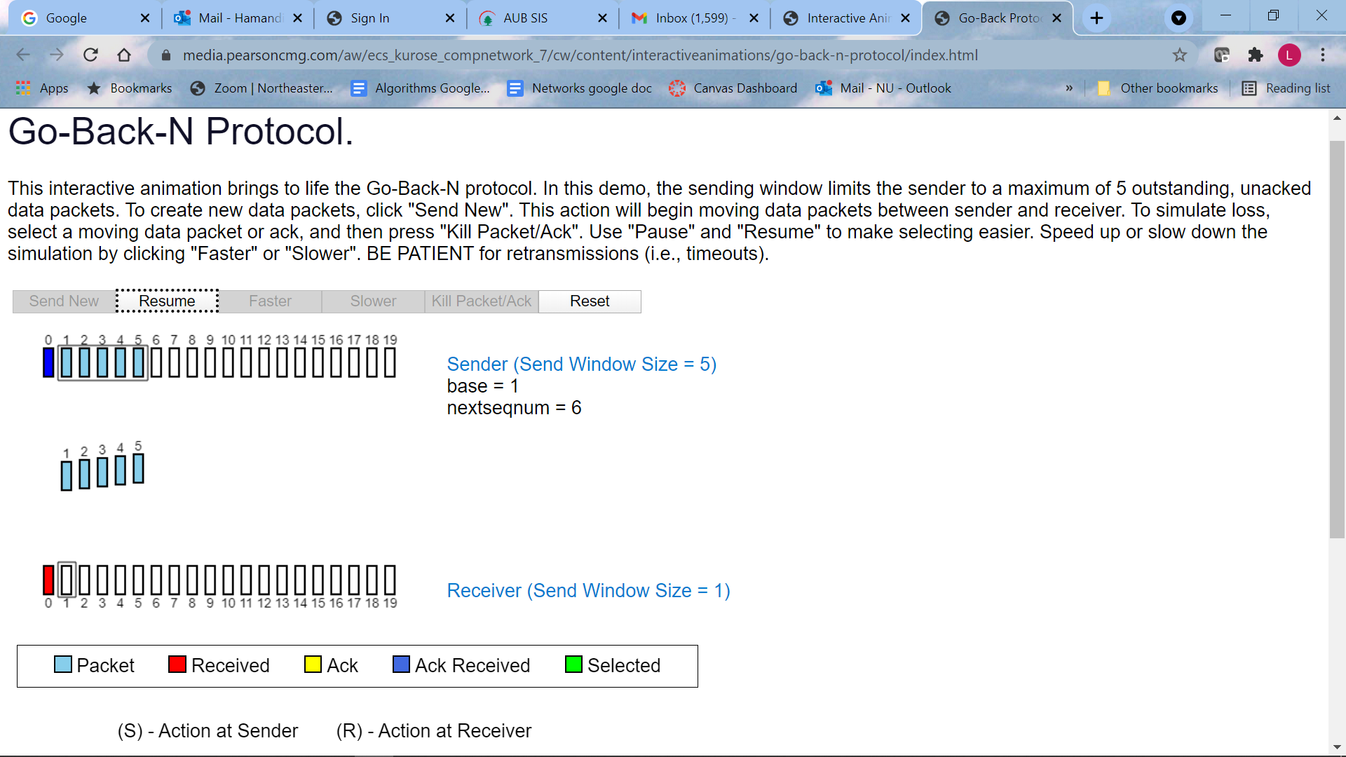

F) After timout, all 5 unacknowledged packets (1 to 5) are retransmitted

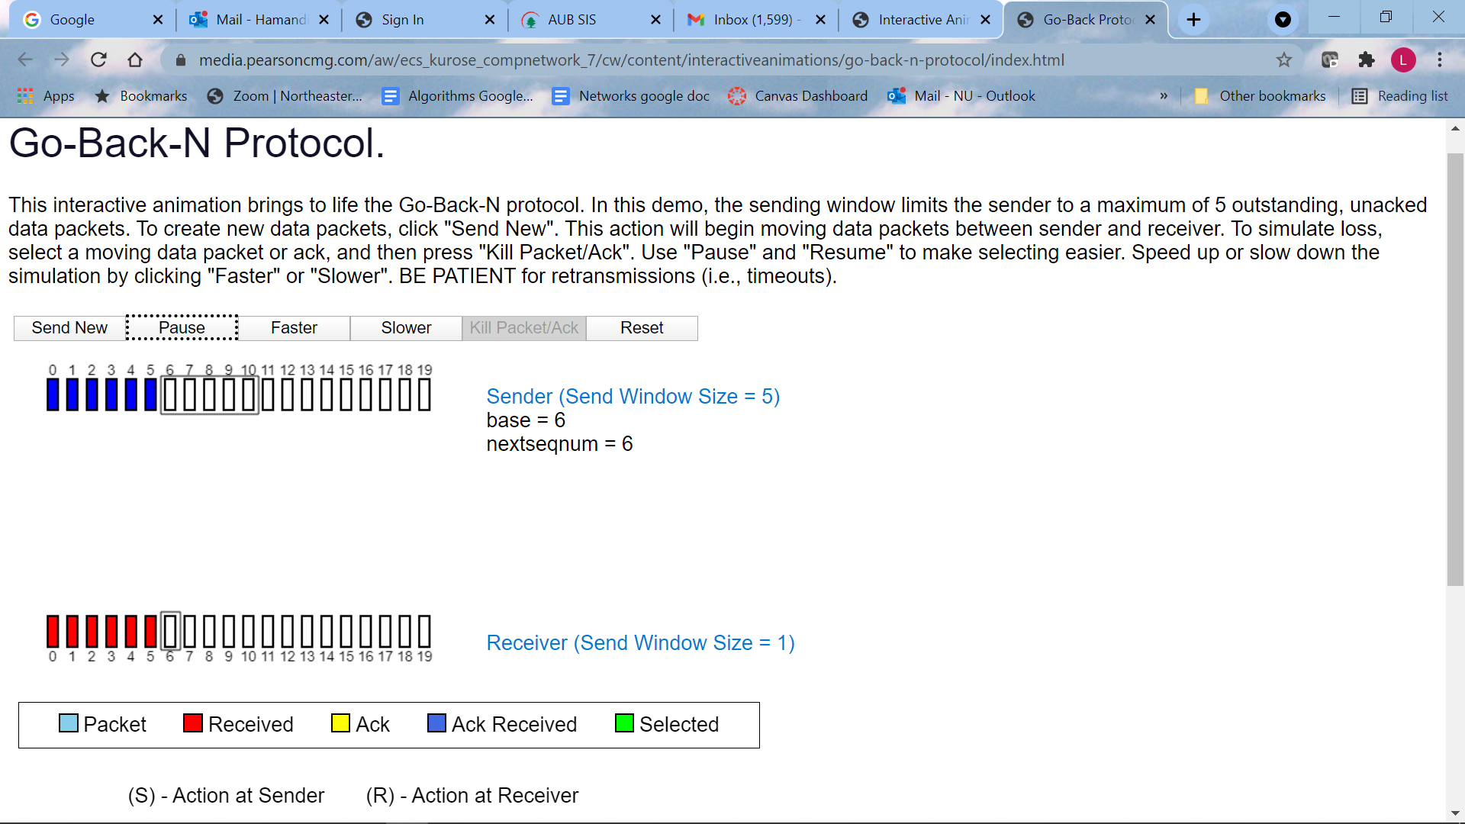

G) packets 1 to 5 are acknowledged and the window moves to 6 to 10

Discussion Work in groups to draw a diagram similar to Figure 3.22 of textbook (repeated here for your convenience) for the following problem: (**Stop after 5 packets are accepted by** **receiver**)

Protocol Used: Go-Back-N

Sliding Window size = 4

Timeout interval = 2RTT

Assume transmission time of a packet = 1/3 RTT

Assume Ack1 is lost, then Packet 2 is lost.

As mentioned in Figure 3.20: The sender starts a timer when it transmits each packet.

When a new (not duplicated) ACK is received, the base (and window) slides to the number of ACK+1.



W = 4

Go-Back-N Solution

P0 sent

P1 sent

A1 lost

P4 sent

P3 sent

A0 rec

P2 sent

P3 discarded, A1 sent

P2 lost

P3 sent

P4 sent

A1 sent

A0 sent

**A1 rec, stop T on P1.** Send P5

P4 discarded, A1 sent

P5 discarded, A1 sent

**Timeout on P2.** Send P2, P3, P4, P5

P5 rec, A5 sent

P3 rec, A3 sent

P4 rec, A4 sent

P2 rec, A2 sent

P5 sent

|  |
| --- |
|  |
|  |
|  |
|  |
|  |
|  |
|  |
|  |
|  |
|  |
|  |
|  |
|  |
|  |
|  |
|  |
|  |
|  |
|  |
|  |
|  |
|  |
|  |
|  |
|  |
|  |
|  |
|  |
|  |

**Selective Repeat**

Sender



1st unack packet

Receiver buffers correctly received packets if out of order



receiver

Question: Why? When can the sender resume sending?

Describe what happens next



**Question 3:**

Repeat Question 2, but now with the Selective Repeat Java applet. How are Selective Repeat and Go-Back-N different?

Visit the Selective Repeat Java applet at the companion Web site:

<https://media.pearsoncmg.com/aw/ecs_kurose_compnetwork_7/cw/#interactiveanimations>

a. Have the source send five packets, and then pause the animation before any of the five packets reach the destination. Then kill the first packet and resume the animation.

Describe what happens.

Answer

Packet 0 is lost. Packets 1, 2, 3, 4 are stored in receiver, and ACK 1, 2, 3,4 are sent to sender. **Sender marks them as received.**

**After timeout**, Pkt 0 is sent again, then when pkt 0 arrives at receiver, pkt 0, 1, 2, 3, 4, are delivered, and ACK0 is sent to sender.

b. Repeat the experiment, but now let the first packet reach the destination and kill the first acknowledgment. Describe again what happens.

pkt 0,1,2,3,4 are received at receiver. ACK 1, 2, 3, 4, are sent to sender. After time out, pkt 0 is sent to receiver, then ACK0 is sent back to sender. and receiver delivers all packets in order to upper layer.

c. Finally, try sending six packets. What happens? Not allowed

d. How are Selective Repeat and Go-Back-N different?

**Disadvantage of Go back N:**

When the window size is large, many packets can be in the pipeline. **A single packet error can thus cause GBN to retransmit a large number of packets**, many unnecessarily.

**Selective-repeat** protocols avoid unnecessary retransmissions by having the **sender retransmit only those packets that it suspects were received in error** (that is, were lost or corrupted) at the receiver.

This individual, as-needed, retransmission will require that the **receiver acknowledges correctly received packets** whether or not they are in order. GBN sends to sender ACK of last correctly received packet.

SR, like GBN, uses a window size of *N* to limit the number of outstanding, unacknowledged packets in the pipeline. However, unlike GBN, the **sender will have already received ACKs** for some of the packets in the window.

in SR, **Out-of-order packets are buffered** until any missing packets (that is, packets with lower sequence numbers) are

received, at which point a batch of packets can be delivered in order to the upper layer.

in GO-Back-N, **out-of-order packets are discarded**. When a packet was lost, GO-Back-N retransmitted all the packets in the sliding window. whereas Selective Repeat retransmitted the lost packet only.

**Advantage of GBN:** In case of **lost acknowledgement**, **selective repeat sent a duplicate ACK** and as **GO-Back-N used cumulative acknowledgment**, so that duplicate ACK was unnecessary.

Discussion Work in groups to draw a diagram similar to Figure 3.26 of textbook for the following problem: (Stop after 5 packets are accepted by receiver)

Protocol Used: Selective Repeat

Sliding Window size = 4

Timeout interval 2 RTT

Assume transmission time of a packet = 1/3 RTT

Assume Ack1 is lost, then Packet 2 is lost.

As mentioned in Figure 3.25:

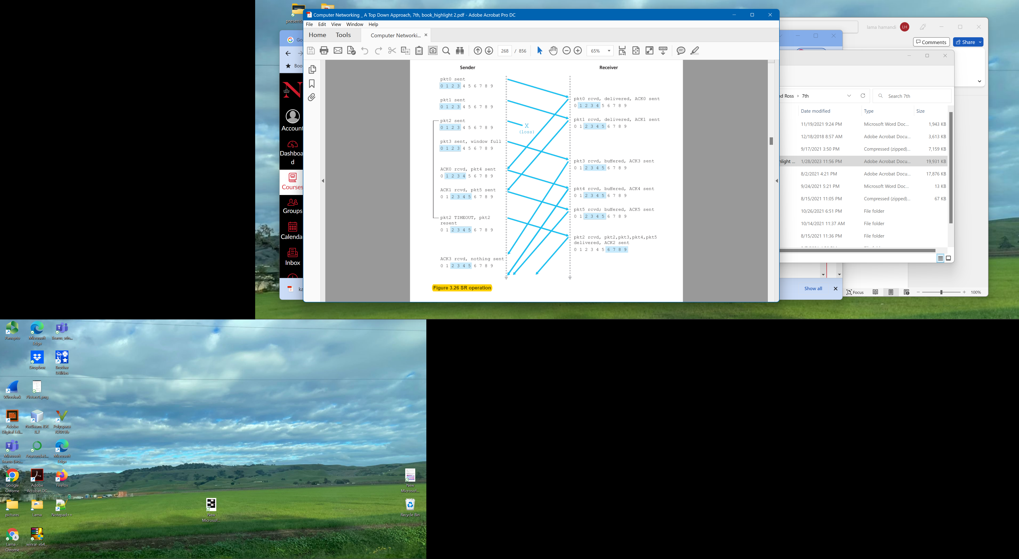

0 1 2 3 4

 

Deliver packets 2, 3, 4

Deliver packet 1

Deliver packet 0